D05 – Complex edition

# Identification data

__**51**__ __**B**__ __**https://github.com/AbrahamSFC/AcmeJobs-DP5**______________   
Group Level GitHub repository   
 (Use a different repository for each deliverable. Make sure that “mary-design-testing” can access it.)

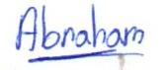__**Sevilla, 18 de Diciembre de 2019**_____________________________________________________  
Place, date

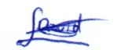 **Abraham García Villalobos, Jefe Proyecto**__  
Student #1: Full name, roles, small picture, and signature

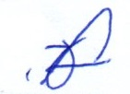___**David Soto Ponce, Analista** ________  
Student #3: Full name, roles, small picture, and signature

__**Jose Delgado Serrano, Desarrollador**_____  
Student #5: Full name, roles, small picture, and signature

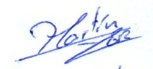**Antonio Fernández Manzano, Desarrollador**_  
Student #2: Full name, roles, small picture, and signature

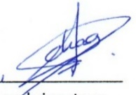**Martín A. Guerrero Romero, Operador**__  
Student #4: Full name, roles, small picture, and signature

_**Chao Hu, Testeador**____________________  
Student #6: Full name, roles, small picture, and signature

# Responsibility statements

[**×**] I have taken into account the guidelines provided in the lectures and document “On your deliverables”, which are available at the USE’s e-learning platform.

[**×**] I understand that I must have a contingency plan and that submitting my deliverable very close to the deadline is likely to result in disaster.

[**×**] I am an author of this deliverable. I have not cheated in any way.

[**×**] I have collaborated with my partners on producing this deliverable; in other words, neither have I ridden their coattails nor gobbled them up.

[**×**] I have learnt from working on this deliverable, so that I can pass my control check.

[**×**] I understand that my deliverable will be considered failed if I fail to meet any of its requirements, if I fail to submit it by the deadline, or if I do not deliver a filled copy of this form.